In this lesson we will create our background and effects using ShaderToy and will go over some of the possible uses for this node so its under filter nodes

  
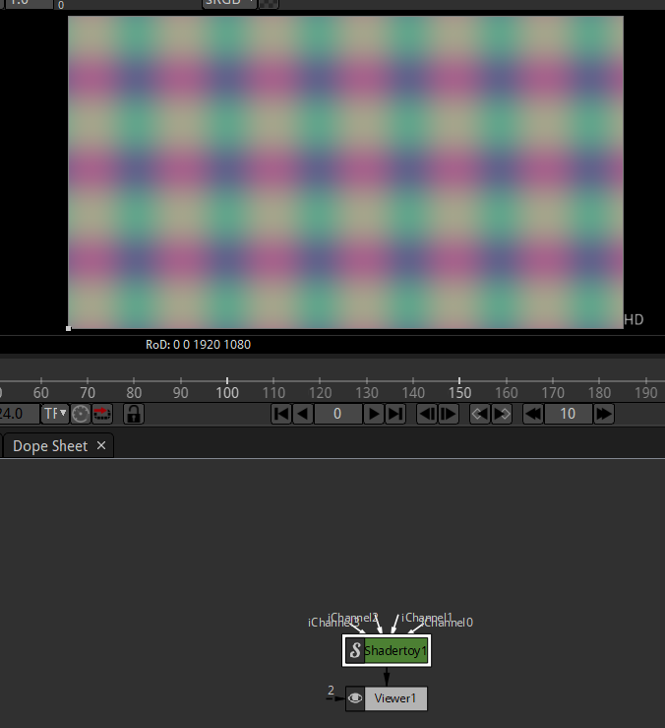

When you connect it first time as shown above then it has kind of this color rainbow

Now as the video progresses frame by frame then the color changes horizontally or vertically

What shder toy is if we look its property

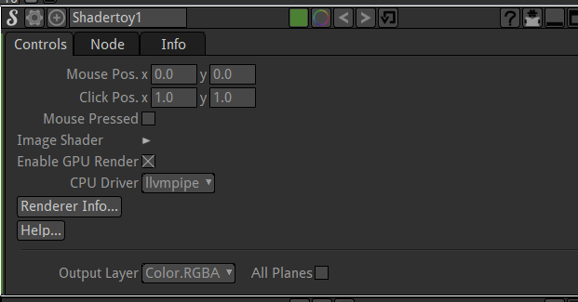

Here we have Image shader expand it to show more option inside it

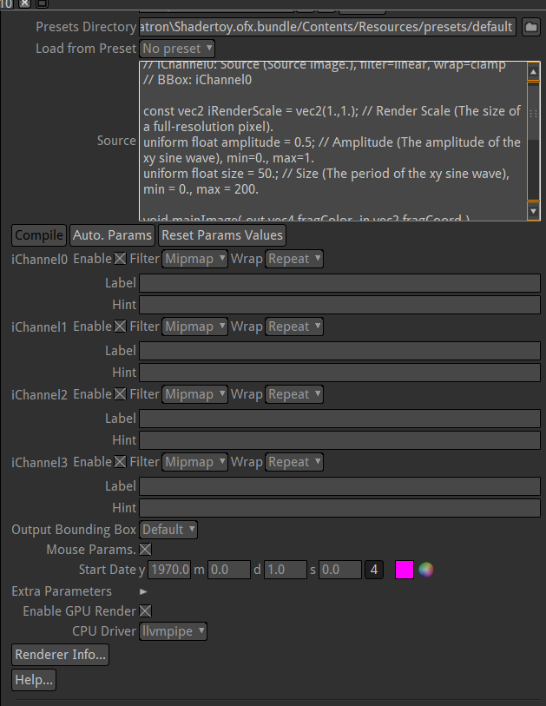

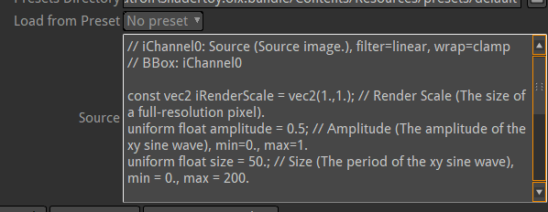

The source contains the instruction for our graphic card

So the shadertoy sends instruction to the graphic card on different ways to render video output

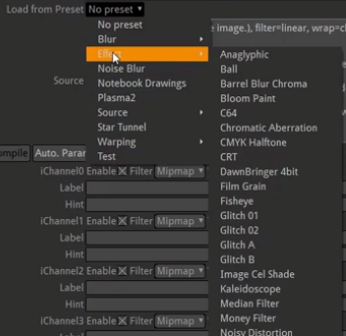

We have all the different present here

So we can apply effects to video here

But each effects have their own identity

Different node of Shader Toy having an effect have different linking configuration

For example Glitch effect will have to link source and sometimes can have multiple source in form of channels and it can exist as a single node as a source for viewer or merge node

1:00

We can use glitch effect that people use some time whenever they are doing something like into animation on youtube videos

You can use old videos effect(inside effect) so that you can make your video look like grainy old look

We can even sharpen our video

We can also render any dynamic background by going to source

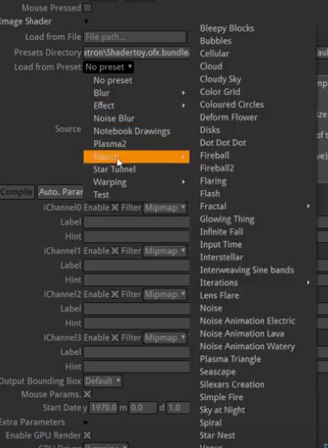

For example if we choose

Source and then to bubbles

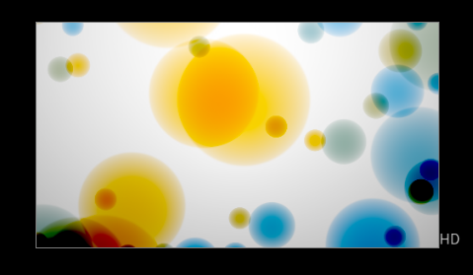

It will show moving bubbles as shown below

Along with shader toy we can apply other effect like ColorCorrect

Or some other filer to apply on it or its definitely more advanced but you can get in modify the actual source code and change the functionality of this preset

And there is a website which you can look upto that is

https://www.shadertoy.com/

Where people have uploaded there code for different shader toy and you can actually download and use these in your project

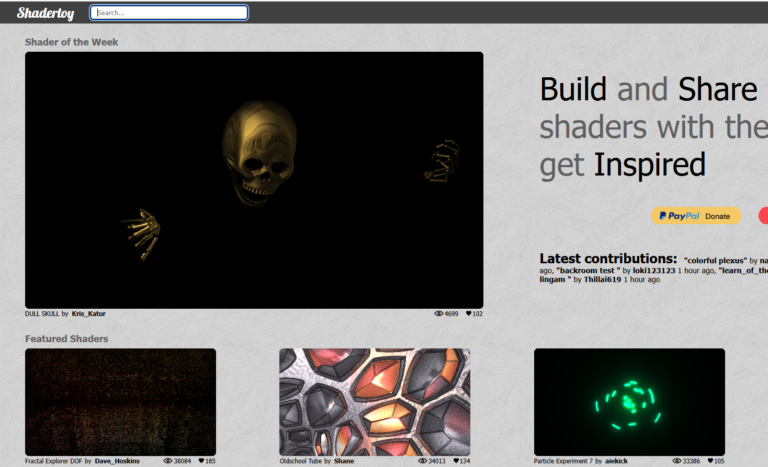

So there’s a whole wide variety of different things you can do with these tool

So we are gonna through couple of them in our shaderToy tool in Natron

For example we can see cloudy Sky in source preset

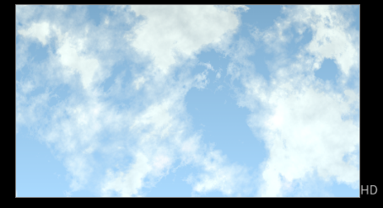

For example Input time

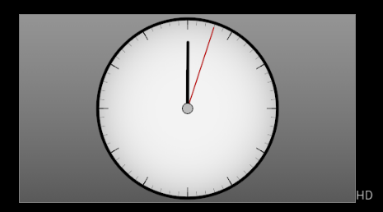

So some of them are not functional like other as the clock minute hand move here only

Some of them are like below

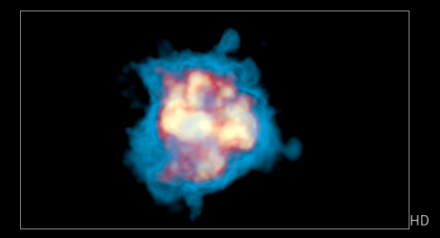

It is fireball’

It is a function ShaderToy effect

You can even modify it and use it as a gunshot flare coming out of the gen or you could make it like sun or star exploding in space

There’s lots of different option you have in ShaderToy properties mirroring the shader Toy you have chosen   
For example fireball have property like density to control the density of the fireball and aphere radius to increase or decrease the size of the fireball

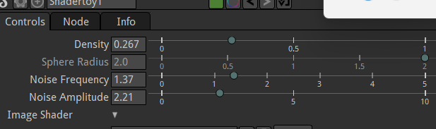

Before increasing the density

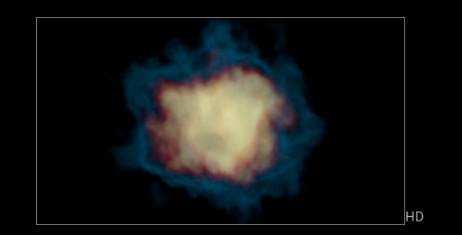

After increasing density

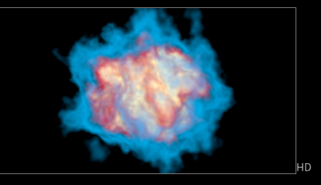

So it is all different ways to modify it

Another example is glowing thing it is shown below

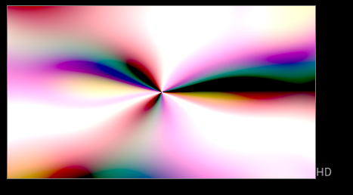

It does not have any property attached to it so we need to modify it by the source code

So it is what glowing thing looks like above

Now comes plasma 2 as shown below

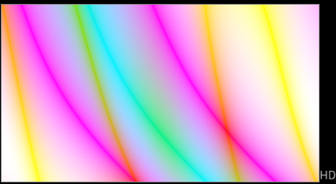

It’s not like we downloaded something that some has created that is being rendered through Mathematics on our computer to our graphic card

So all of this can be used like the sky we rendered before now we see night sky

Now we see star nest

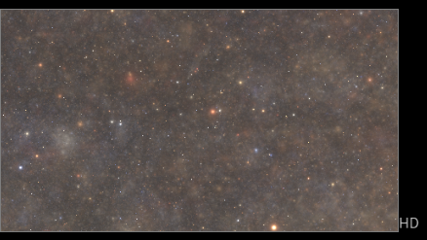

We can use these stars and have Ship flying through there

It’s not we have to get licensing or anything from the creater of this because the creater is just math in this case

4:20

Go through with different shaders sources   
You can apply different effects of ShaderToy to different videos

Advice:-

It will be better if you apply effects on a particular object rather than a whole video

Now play with it all Import videos and play woth difernt shader ob how will they react

We will use this more as we go deeper in natron